

The University Museum

Department of Archaeology

University of Nottingham

University Park

Nottingham

NG7 2RD

**Curator: Clare Pickersgill**

Resource created by Jo Catling of Aln Heritage for The University Museum

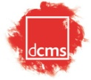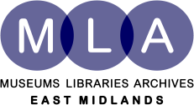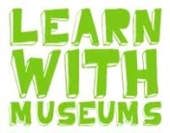© All materials copyright of The University Museum unless otherwise stated.

**Page No.**

**Contents 3**

**Introduction 4**

**Handling Care 5**

**Margidunum 6**

**The Pottery Box 7**

**The Posters 8**

**Civic Life 9**

**Clothing and Adornment 10**

**Domestic Life 11**

**Cooking and Eating 12**

**Personal Care 13**

**Follow up and Feedback 14**

**Resource Contents 15**

**Further information/ Acknowledgements 17**

**A Museum in a trunk!**

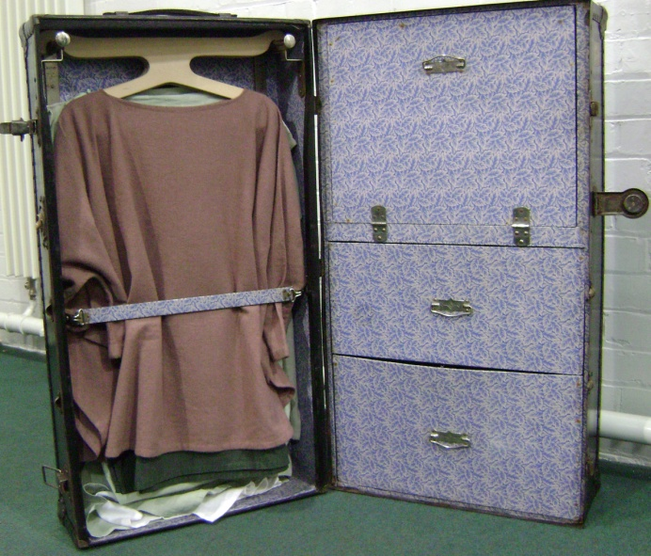

That was our original inspiration - an exciting collection of real and replica artefacts and costumes that would bring the Roman past alive.

At its simplest this is a handling collection but it is also

* a dressing up box
* an archaeological treasure trove
* a journey into the past
* a mini museum

**The Resource**

The artefacts and posters in the trunk are based on finds made in and around Bingham, Nottinghamshire. These come from the Roman site of **Margidunum** and its hinterland. Included are fragments of Roman metal work, pottery and building materials along with replicas of items in the museum collection.

There are also resources and instructions for a number of activities including Roman games, clay work and recipes for beauty products.

**Themes**

Although there are artefacts within Nottingham University Museum that reflect the military nature of the site during first century AD, most of the collection represents a more urban community of people taking advantage of the trading opportunities offered by the Fosse Way. It is this later and longer lasting phase of Margidunum’s history that we have focused on in this resource.

The contents of the trunk are roughly divided into five main themes

* **Civic Life**
* **Domestic Life**
* **Personal Care**
* **Clothing and Adornment**
* **Cooking and Eating**

Each theme is supported by a range of artefacts, information cards, archaeological material and suggestions for activities.

Supplementary images and resources can be found on the accompanying CD-ROM and on the Museum website.

As you and your pupils become familiar with the resource we suggest you explore other ways of categorising the collections, for example, by material or status.

**Whilst it is in your possession it is your responsibility to make sure that the trunk and the pottery box along with their contents are treated with respect and handled with care.**

A full list of contents is given at the back of this pack and a checklist is included in each section of the trunk to encourage your group to take responsibility for packing away the resource.

**Points to consider:**

* Think carefully when positioning the trunk. Although it is very stable it should be placed where it won’t get knocked into.
* The trunk should only be closed by the adult responsible for the group.
* **Do not attempt to lift the trunk**. Always use the trolley to move it.
* Make sure that the back of the pottery box is secured.
* When handling artefacts make sure everyone is sitting down. Don’t pass artefacts whilst moving round the room, always pass them across a desk, that way if they are dropped they have less distance to fall.
* Use the protective mats, particularly when handling glass and pottery.
* Take care when handling the artefacts, particularly the pottery sherds. Some of the edges may be a little sharp and some items have pointed ends, e.g. the bronze spoons and styli.
* Particular care should be taken with small items such as the Roman coins and brooch fragments.
* Don’t leave artefacts unsupervised.
* Use the magnifying glasses to look at the details.
* When making make up, don’t apply it to the face just in case there is an allergic reaction; test it out on the back of the hand.
* Most items are in their own box or packet. Make sure they are packed away at the end of each session, that way they are less like to get lost.

**However, the most important thing is that the resources are there to be used and for everyone’s enjoyment.**

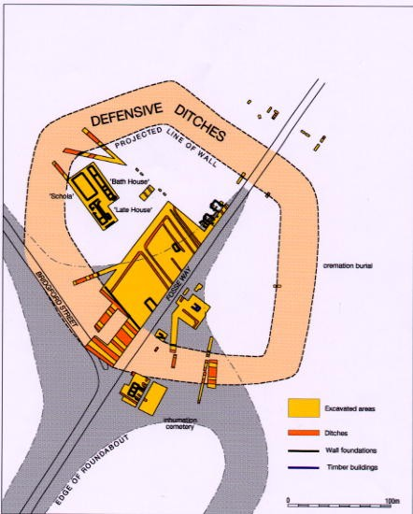**Excavation & discovery**

Parts of the Margidunum site were excavated by Felix Oswald in the late nineteenth/early twentieth centuries; Malcolm Todd further excavated the site in the 1960s. Since then more information has been gained from surveys made in advance of road building schemes and extensive field walking.

**Early Margidunum**

Roman occupation of the site first occurred in the middle of the first century AD, not long after Claudius invaded Britain. The artefacts recovered dating to this period include Samian Ware, spearheads and armour fittings, items that indicate that Margidunum was a military site during this early phase.

Many buildings were made of wood but finds of window glass, stone window arches and other worked stones suggest some buildings were more elaborate. The site may have been a staging post for soldiers travelling along the **Fosse Way,** possibly protected by a wooden fort to the north of the defences shown on the plan.

**The Fosse Way** ran from Lincoln to Exeter and it is likely that it followed an ancient track way used by the British. It was an important route bringing communications and supplies to soldiers on the border between Roman Britain and the unconquered lands in the north.

**Second century onwards**

In about AD 70 the Roman army moved northwards and the importance of the Fosse Way diminished. Margidunum probably became a local administrative centre and station post for travelling imperial officials. This centre attracted tradesmen and crafts people who settled and built workshops, exploiting the trading links afforded them by the Fosse Way that stretched from the east coast to the west of Britain.

The evidence suggests that Margidunum grew into a prosperous small town surrounded by farmland. Field walking finds suggest that there may be several villas occupying its hinterland. In many ways it would have been much like modern Bingham is today.

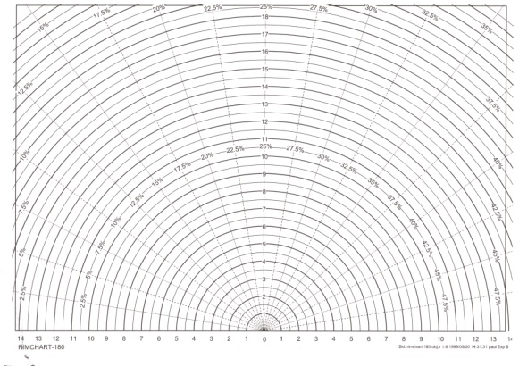**The Pottery Box** is designed be used as a stand-alone exhibition. It consists of the box with five drawers and two supports, a poster, *rim charts, mats and magnifying glasses.

To use the box, lift up the lid and pull out the top tray. Remove the contents and take out the tray can be removed, giving access to the remaining boxes.

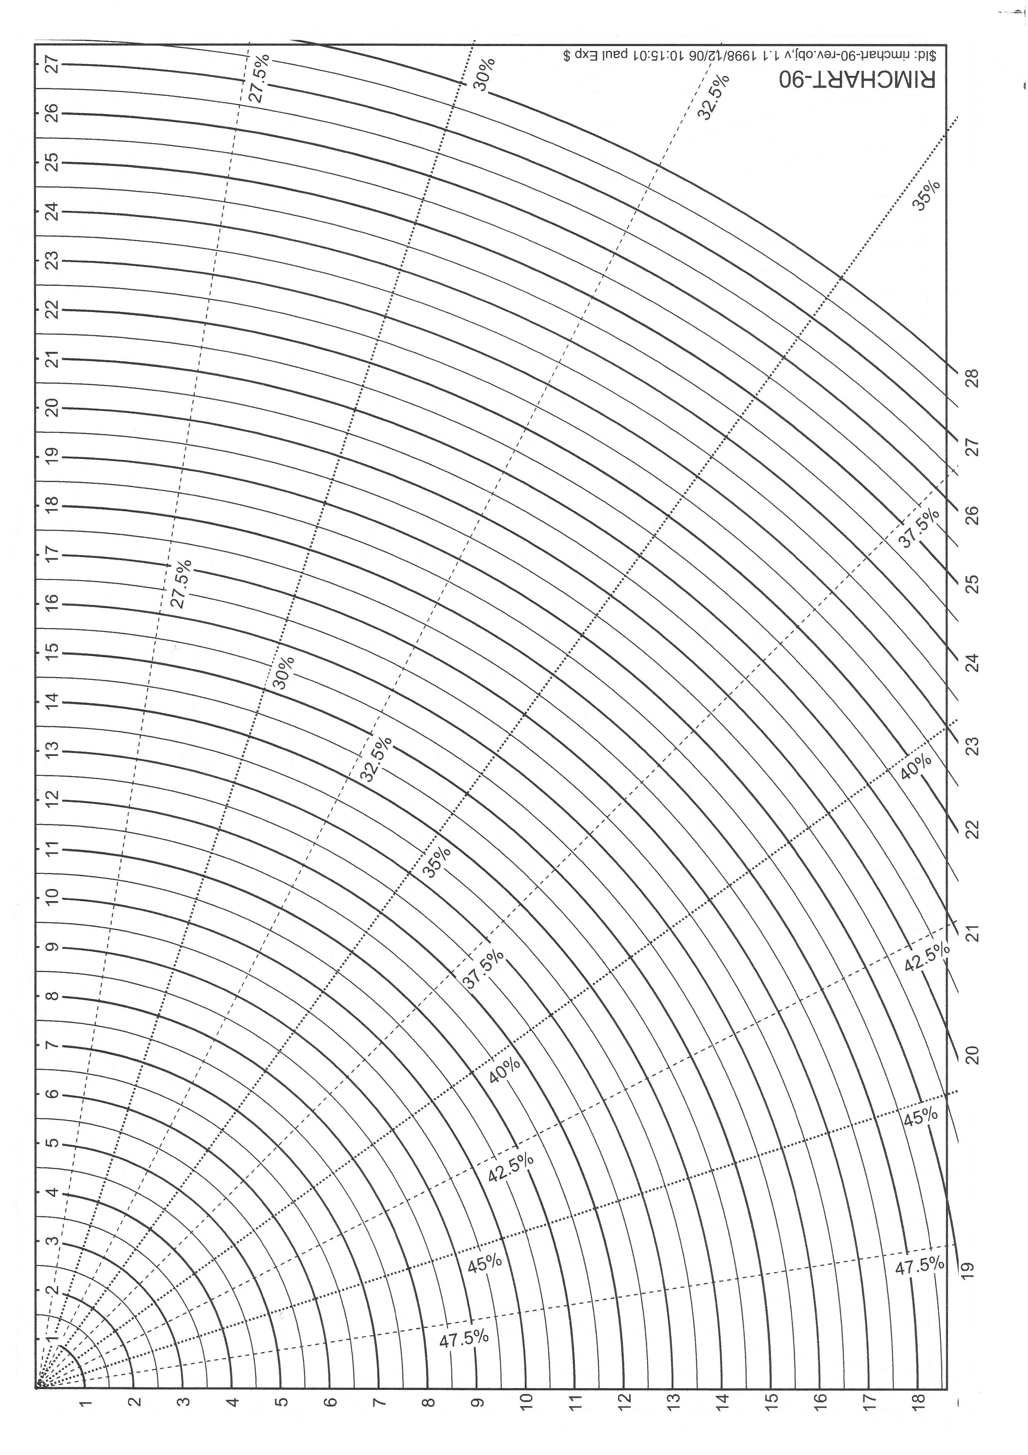Fix the two supports (stored in the top tray) behind the lid to make it secure. The back and top of the box now become a space to which the poster can be attached and the pots displayed.

**The Pots**

A separate *identification chart for the pottery is included in the box.

Each pot is a replica of one in the Museum collection and fragments from each type of pot are included in the archaeological handling collection.

On the CD there are brief slide shows showing the potter making the moulds for the Samian Ware bowl and Mother Goddess and stages in making the lip for the mortarium.

**Rim Charts**

There are two types of rim chart included in the box, 90˚ and 180˚; each can be used to determine the circumference of a pot base or rim giving some idea of its full size.

Both charts are calibrated along their axes at .5cm intervals; the radial divisions mark the percentage of the whole pot measured at intervals of 2.5%.

**Circumference Chart (180˚)**

**Radius Chart (90˚)**

**To measure** a piece of pottery, place the sherd on the centre of the chart and slide it slowly towards the edge of the sheet, stopping when the curve of the shard matches the curve on the chart. Read the measurement from the scale along the edge of the chart.

* In the top drawer of the trunk

**There are** five posters to accompany the collection as well as a variety of information cards for pupils to use.

All the information comes from the various reports and surveys undertaken at Margidunum and the surrounding area. It is as accurate as possible **but** as survey methods become more subtle and sophisticated so our knowledge base increases and the picture changes.

It is important to stress to your pupils that the understanding archaeologists have now of the site is constantly evolving; what may have been accepted 40 years ago is now under scrutiny. Encourage them to look at the evidence and make their own interpretations of the site.

**The Posters**

* **Poster 1: Margidunum, a lost town on the Fosse way**

Introduction to the site of Margidunum and its historical background; includes a map of Roman roads in Britain and an aerial photograph of the site.

* **Poster 2: In search of Margidunum**

An outline of the archaeological research of the site, featuring a plan and archive photographs of the original dig.

* **Poster 3: Roman Hairstyles**

This poster accompanies the hairstyling head and style ‘booklet’. The images come from Sir John Saone’s Museum in London.

Faustina was the wife of Emperor Marcus Aurelius (reigned 161 –180 AD), Plautilla was married to Emperor Caracella (reigned 211–217 AD).

* **Poster 4: Inside a Roman Townhouse**

This is a composite house based on various finds from the site at Margidunum. The painted plaster, mosaic flooring and heating system all indicate a degree of affluence amongst some members of the population. The workshop and yard show that this building was a business premises as well as a home. Houses like this may have had a frontage on to the Fosse Way to take advantage of the passing trade.

* **Poster 5: Pots, Pots and more Pots!**

This poster highlights some of the processes involved in making Roman pottery. It is designed to be attached to the pottery box lid.

**Info Sheets**

Each theme has a card with images of related artefacts from the collection accompanied by a brief description of the object and its function.

🞟🞟🞟🞟🞟🞟🞟

**The following** pages outline the resources we have assigned to each theme and give suggestions for related activities.Many of the resources for the activities are included and these are marked **\*** but some will need additional materials to complete.

**Artefacts in Trunk**

Writing tablets x 2

Stylus x 2

Ink well

Large square bottle

Coins

Bone gaming pieces x 20

Yellow glass gaming pieces x 10

Blue glass gaming pieces x 10

Horn dice shakers x 4

Die x 6

Gaming boards x 3

Goddess statuette

**Images on Disc**

Scales

Potter at work

Face pot slide show

Adze

Nails

Roof tile

Roof slate

Gaming counters

Armed warrior god

Coins with religious motifs

**Posters etc**

Inside a Roman Townhouse

In Search of Margidunum

Pots, Pots and more Pots!

**Archaeological evidence**

Roof tile (*tegula*)

Ridge tile

Floor tile

Concrete (*opus signum*)

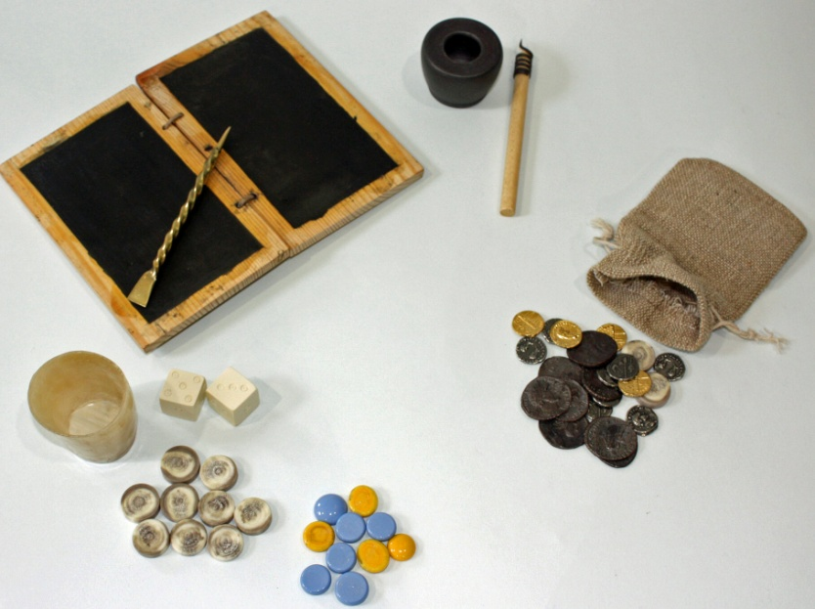

Nails

Box flue

Coins

**Activity Suggestions**

***Play Roman games***

Equipment:

Die **\***

Shaker **\***

Counters **\***

Rules of play **\***

***Make your own ink***

Equipment:

Soot

Gum Arabic (available from art suppliers)

Vinegar

Mixing pot and stirrer

Instructions **\***

***Make a pinch pot***

Equipment:

Self hardening clay

Decorative stamps **\***

**\***included

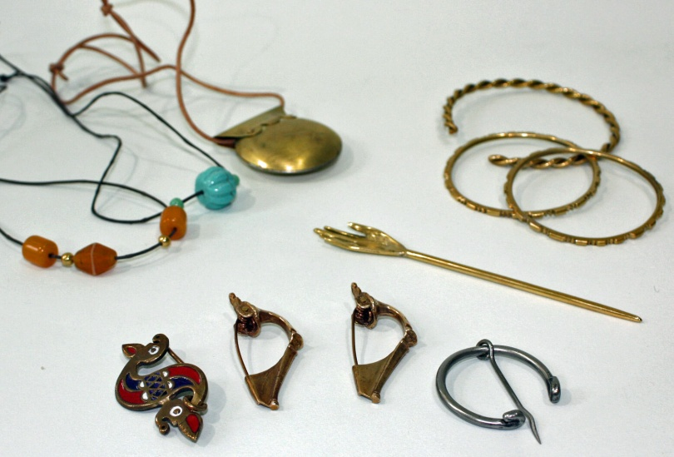**Artefacts in Trunk**

Bulla

Dragonesque brooches x 2

Penannular brooches x 6

Bangles x 4

Twisted wire bangle

Trumpet brooches x 2 Shoes x 2 pairs

Sandals x 2 pairs

Spare belts x 2

**COSTUMES**

***Hanger 1 (man)***

Gallic coat

Green tunic & cord

***Hanger 2 (child)***

Dark grey tunic & cord

***Hanger 3 (woman)***

Long white tunic & cord

Mauve peplos & cord

***Hanger 4 (woman)***

*Green peplos with cord*

***Hanger 5 (slave)***

Natural coloured tunic & cord

**Images on Disc**

Leather shoe

Fibula (brooch)

Ring

Twisted wire bracelet

Dragonesque brooch

**Posters etc**

Two booklets showing how to wear the clothes

**Archaeological evidence**

Brooch fragments

**Activity Suggestions**

***Dressing up and role play***

Equipment:

Costumes **\***

Artefacts **\***

Pottery sherds **\***

Use the artefacts and costumes to encourage pupils to adopt a persona; create dialogues relating to their status – wife, daughter, slave etc.

***Have a go at*** ***spinning***

Equipment:

Wool **\***

Spindle **\***

Instructions **\***

**\*** included

**Artefacts in Trunk**

Glass indented beaker

Glass jug

Glass flask

Small square glass bottle

Antler needles

Weaving heddle x 3

Shuttles x 3

Drop spindles with bone whorls x 3

Drop spindles with clay whorls x 2

Mother goddess

**Artefacts in Pottery Box**

Carinated bowl/drinking cup

Lamps x 2

**Images on Disc**

Bucket and furniture handles

Latch lifter

Door hinge

Box flue

Painted wall plaster

Mosaic

Roman town house drawing

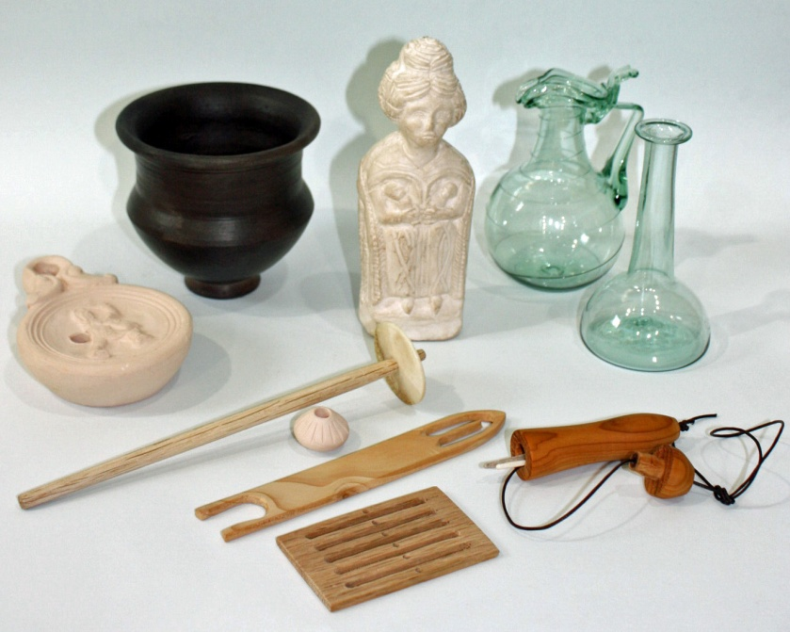**Poster**

Inside a Roman Townhouse

**Archaeological evidence**

Lamp handle

Nail

Tesserae

Plaster

Tile

Box flue fragment

**Activity Suggestions**

***Braid weaving with a heddle***

Equipment:

Heddle**\***

Shuttle**\***

Cotton embroidery thread

Instructions **\***

***Votive offerings***

Equipment:

Self-hardening clay

Metal foil or metallic card

The Romans made representative offerings to the gods in exchange for healing. For example, someone with earache might leave a clay ear at the household shrine.

Ask pupils to design and create offerings for illnesses and events.

**\*** included

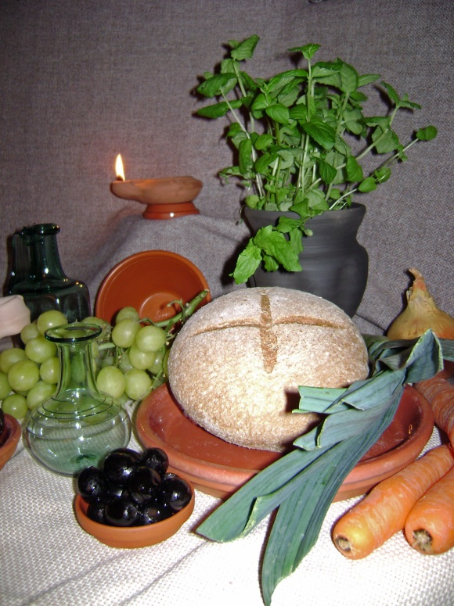

**Artefacts in Trunk**

Large square bottle

Bronze spoons x 2

Antler handled knife

Glass indented beaker

**Artefacts in Pottery Box**

Cooking pot

Mortarium and pestle

Nene Valley beaker

Samian Ware plate

Samian Ware bowl

Samian Ware cup

Pie dish

**Images on Disc**

Grid iron

Ladle

Saucepan

Roman foodstuffs

**Archaeological evidence**

Pottery sherds:

Mortarium

Samian Ware

Handles

Amphora handle

Cooking pot rims

Neck of jar

Oyster shells

**Activity Suggestions**

***Grow a Roman herb garden***

Equipment:

Container e.g. grow bag, tub, raised bed

Compost

Suggested plants: rosemary, mint, lovage, thyme, parsley

***Make Roman Bread***

Equipment:

Recipe *

Scales

Sieve

Mixing bowl

Teaspoon

Mixing spoon

Measuring jug

Baking trays

Ingredients:

Spelt flour

Salt

Olive oil

Honey

Easy blend yeast

**\*** included

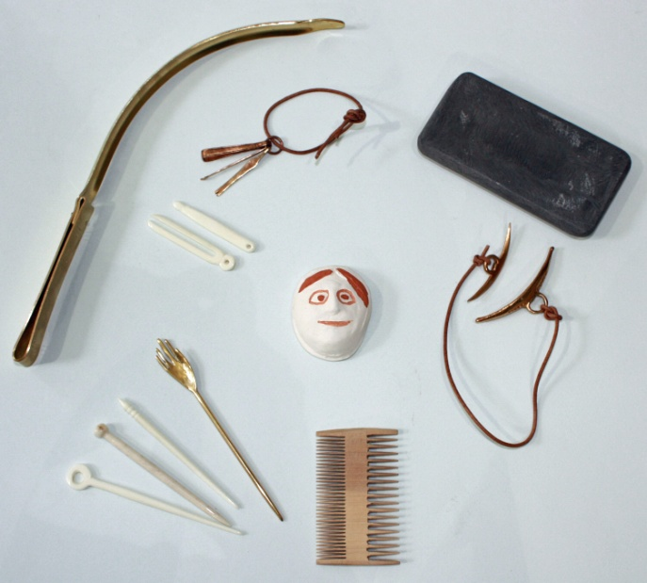**Artefacts in Trunk**

Cosmetic palette and spatula

Cosmetic grinder

Bronze cosmetic set

Bone tweezers

Bone scoop

Antefix

Styling head and clamp

Wooden combs x 2

Hairstyling ‘booklet’

Beauty Tips ‘booklet’

Hairpins – bone x 8 (2 each of 4 designs), brass x 4

Brass hand hair pin

Small glass phial

**Artefacts in Pottery Box**

Face flagon

**Images on Disc**

Cosmetic grinder

Pottery face plaque (antefix)

Hairstyles from coins

Plautilla, drawing and photograph

Faustina, drawing and photograph

**Posters etc**

Hair poster

Hair styling book

Beauty tips book

**Activity Suggestions**

***Roman hairstyles***

Equipment:

Styling head and clamp **\***

Hairstyle booklet **\***

Wooden comb **\***

Hairpins **\***

***Make your own beauty products***

Equipment:

Beauty tips booklet **\***

Cosmetic grinder **\***

Cosmetic palette **\***

Sponges **\***

Haematite **\***

Beeswax

Olive or almond oil

Borax

Rosewater

***Pottery face plaque***

Equipment:

Pottery moulds x 4 (in pottery box)*

Self hardening clay

Paint

**\*** included

**Once your** pupils are familiar with the collection consider setting up a class/school museum and invite parents and other classes to visit.

Ideas to consider:

***The Collection***

* What will go on display?
* How will artefacts be organised?

***Audience***

* Who will be the audience?
* How will this influence the way the collection is set out?

***Labels***

* What information should be included?
* How will it be presented? Consider paper and font colour, style and size.
* What are the most important things the audience should know?
* Do you want to explain what things were used for or do you want your visitors to think about it themselves?

***Leaflets and signs***

* How will the Museum be promoted? Consider leaflets, posters, advertisements on school notice-boards and website, fliers for parents. Images on the accompanying CD could be helpful here.
* Does it need a logo?
* Will there be a shop or café?

**A trunk** is for travelling and as the collection travels around our region we hope that you will add to it in the following ways

* by creating a destination label for your school and applying it to the outside of the trunk
* by photographing the trunk and its contents on display in your school
* by encouraging your pupils to write and illustrate stories about the artefacts and their owners. Add these to the log book for everyone to enjoy.

At the end of the year the University hopes to host an exhibition based on the travels of the trunk which will include examples of the above.

It is also our eventual aim to use the best of the stories about the artefacts as a basis for a children’s book.

🞟🞟🞟🞟🞟🞟🞟

**Finally**,we would ask that you complete the accompanying evaluation form and return it to:

**Clare Pickersgill**

The University Museum

Dept. of Archaeology

University of Nottingham

University Park

Nottingham

NG7 2RD

**TRUNK CONTENTS**

**COSTUMES**

***Hanger 1 (man)***

Gallic coat

Green tunic & cord

***Hanger 2 (child)***

Dark grey tunic & cord

***Hanger 3 (woman)***

Long white tunic & cord

Mauve peplos & cord

***Hanger 4 (woman)***

*Green peplos with cord*

Stola

***Hanger 5 (slave)***

Natural coloured tunic & cord

**DRAWER 1- ARCHAEOLOGICAL EVIDENCE & SUPPORT MATERIALS**

Nail

Tesserae

Plaster

Tile

Box flue fragment

*Pot sherds:*

Mortarium

Samian Ware

Handles

Amphora handle

Cooking pot rims

Lamp handle

Neck of jar

Oyster shells

Roman coins x 13

Brooch Fragments x 7

***Activities & support materials***

Rim charts x 6

Gaming boards x 3

Instructions for games x 6

Pottery identification chart x 6

Costume booklets

Costume details

Magnifying glasses x 6

**DRAWER 2**

***Left side – Domestic life***

Lamps x 2

Small square glass bottle

Glass indented beaker

Glass jug

Glass flask

Drop spindles with bone whorls x 3

Drop spindles with clay whorls x 2

Weaving heddle x 3

Wool

Shuttles x 3

Antler needles x 3

Needle case

Bronze spoons x 2

Antler handled knife

How to - make Roman Bread

***Right side – Civic Life***

Writing tablets x 2

Stylus x 2

Ink well

Pens x 2

Large square bottle

Replica coins in pouch x 25

Bone gaming pieces x 20

Glass gaming pieces (yellow) x 10

Glass gaming pieces (blue) x 10

Horn dice shakers x 4

Die x 6

Goddess statuette

How to – make ink

**DRAWER 3**

***Left side***

Head

Wooden combs x 2

Hairstyling ‘book’

Make up tips ‘book’

Haematite

Sponges

***Right side***

Hairpins – bone x 8 (2 each of 4 designs), brass x 4,

Brass hand hairpin

Cosmetic palette

Bronze scoop (ligula)

Cosmetic grinder

Bronze cosmetic set

Bone tweezers

Bone scoop

Dragonesque brooches x 2

Trumpet brooches x 2

Penannular brooches x 6 iron, 2 brass

Bangles x 4

Bead necklaces x 2

Twisted wire bangle

Bulla

Additional belts x 3

Leg wrappings + thongs x 1 pair (puttees)

Strigil

Shoes (carbatinae) x 2 pairs

Sandals (solae) x 2 pairs

Antefix

Small glass phial

Strigil

Sponge on a stick

**POTTERY BOX CONTENTS**

**DRAWER 1 (Top)**

Mortarium

Pestle

Glass ball

Large mortarium pot sherd

Mats x 6

Supports x 2

**FRONT DRAWER 2 (Bottom)**

Samian Ware mould

Samian Ware bowl

Samian Ware plate

Samian Ware cup

Clay stamps in box

Samian Ware pot sherds x 3

**FRONT DRAWER 3 (Top)**

Face pot

Pie dish

NeneValley Beaker

Carinated bowl

Pie dish pot sherd

**BACK DRAWER 4 (Left)**

Cooking pot

Two pot sherds (one large)

**BACK DRAWER 5 (Right)**

Face flagon

Face mould x 4

For more information about the Roman site of Margidunum and its hinterland from Bingham Heritage Trails Association:

[**http://www.binghamheritage.org.uk/**](http://www.binghamheritage.org.uk/)

For information about Nottingham University Museum:

[**http://www.nottingham.ac.uk/museum/**](http://www.nottingham.ac.uk/museum/)

An informative clip featuring Russell Hart – Davies and Sally Pointer demonstrating the application of Roman make-up:

**http://www.youtube.com/watch?v=utdeCvlNppM**

**Acknowledgements**

**Nottingham University Museum** would like to acknowledge the help given by

Virginia Baddeley, Lee Elliot and David Knight of Trent and Peak Archaeology Unit, **http://www.nottingham.ac.uk/tpa**

Peter Allen from Bingham Heritage Trails Association, **http://www.binghamheritage.org.uk**

Sir John Soane’s Museum, London

**http://www.soane.org**

Arlene Rankin for design and layout of the posters

David Hopkins for the house and hairstyle poster illustrations

Clare Taylor who made the costumes

Grahame Watson

Graham Taylor, Potted History

**http://www.pottedhistory.co.uk**

Adrian Winks, *Armamentaria*

**http://www.armamentaria.com**

Mary & Malcolm Fisher, *Sweetness and Light* **http://www.candlemaker.org.uk**

